**Netaji Subhash University of Technology**



**DEEP LEARNING PROJECT**

STOCK ANALYSIS REPORT FILE

**SUBMITTED BY-**

2020UEA6576

VANSH GUPTA

**SUBMITTED TO-**

Prof Rashmi Gupta

**INTRODUCTION**

Stock analysis is the evaluation of a particular trading instrument, an investment sector, or the market as a whole. Stock analysts attempt to determine the future activity of an instrument, sector, or market.

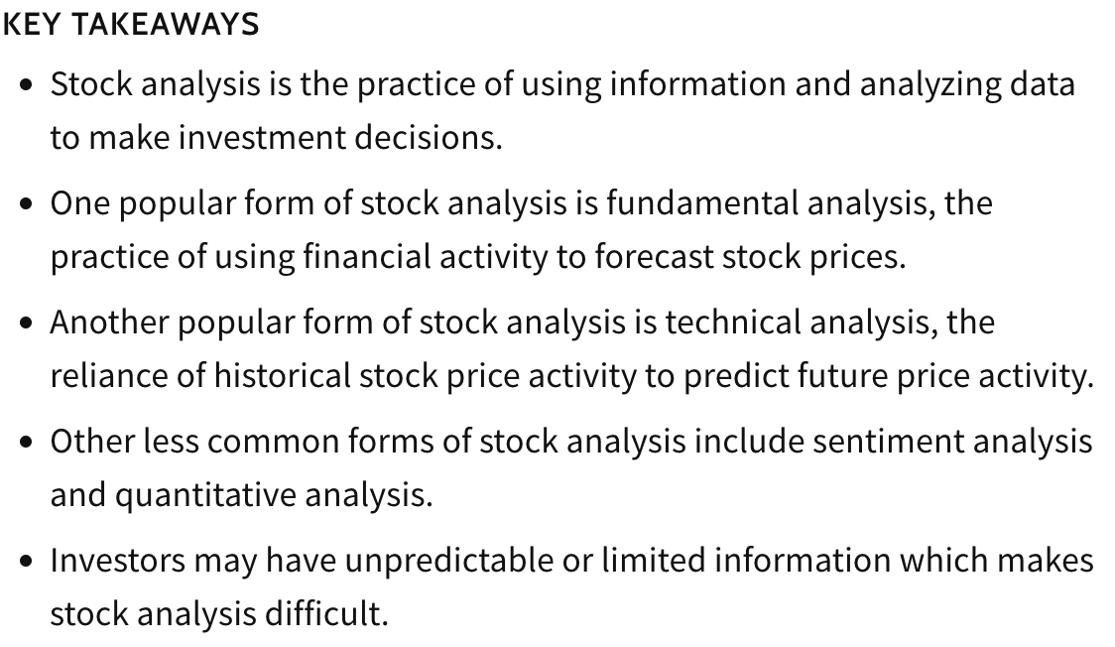

**UNDERSTANDING STOCK ANALYSIS**

Stock analysis is a method for investors and traders to make buying and selling decisions. By studying and evaluating past and current data, investors and traders attempt to gain an edge in the markets by making informed decisions.

The notion of stock analysis relies on the assumption that available market information can be used to determine the intrinsic value of a stock. In the primary methods discussed below, investors use financial statements, stock price movement, market indicators, or industry trends to make investment decisions.

Much of this strategy relies on leveraging historical information. For instance, investors may analyze a company's stock based on it's financial performance. An analyst that is trying to determine the fair price of that stock may strive to understand how similar companies of similar performance performed in the past.

There are two basic types of stock analysis: [fundamental analysis](https://www.investopedia.com/terms/f/fundamentalanalysis.asp) and [technical analysis](https://www.investopedia.com/terms/t/technicalanalysis.asp). Each method is discussed more in-depth below.

## FUNDAMENTAL ANALYSIS

Fundamental analysis concentrates on data from sources, including financial records, economic reports, company assets, and market share. To conduct fundamental analysis on a public company or sector, investors and analysts typically analyze the metrics on a company’s [financial statements](https://www.investopedia.com/terms/f/financial-statements.asp) – [balance sheet](https://www.investopedia.com/terms/b/balancesheet.asp), [income statement](https://www.investopedia.com/terms/i/incomestatement.asp), [cash flow statement](https://www.investopedia.com/terms/c/cashflowstatement.asp), and [footnotes](https://www.investopedia.com/terms/f/footnote.asp).

These statements are released to the public in the form of a [10-Q](https://www.investopedia.com/terms/1/10q.asp) or [10-K report](https://www.investopedia.com/terms/1/10-k.asp) through the database system, [EDGAR](https://www.investopedia.com/terms/e/edgar.asp), which is administered by the U.S. [Securities and Exchange Commission](https://www.investopedia.com/terms/s/sec.asp) (SEC). Also, the earnings report released by a company during its quarterly earnings press release is analyzed by investors who look to ascertain how much in revenue, expenses, and profits a company made.

**TECHNICAL ANALYSIS**

The second method of stock analysis is technical analysis. Technical analysis focuses on the study of past and present price action to predict the probability of future price movements. Technical analysts analyze the financial market as a whole and are primarily concerned with price and volume, as well as the demand and supply factors that move the market.

Charts are a key tool for technical analysts as they show a graphical illustration of a stock’s [trend](https://www.investopedia.com/terms/t/trend.asp) within a stated time period. For example, using a chart, a technical analyst may mark certain areas as a [support](https://www.investopedia.com/terms/s/support.asp) or [resistance](https://www.investopedia.com/terms/r/resistance.asp) level. The support levels are marked by previous lows below the [current trading price](https://www.investopedia.com/terms/c/currentprice.asp), and the resistance markers are placed at previous highs above the current [market price](https://www.investopedia.com/terms/m/market-price.asp) of the stock. A break below the support level would indicate a [bearish trend](https://www.investopedia.com/terms/b/bearmarket.asp) to the stock analyst, while a break above the resistance level would take on a [bullish outlook](https://www.investopedia.com/terms/b/bullmarket.asp).

**INTRODUCTION TO LSTM**

Long short term memory (LSTM) is a model that increases the memory of recurrent neural networks. Recurrent neural networks hold short term memory in that they allow earlier determining information to be employed in the current neural networks. For immediate tasks, the earlier data is used. We may not possess a list of all of the earlier information for the neural node. In RNNs, LSTMs are very widely used in Neural networks.

One of the main issues with RNN is the vanishing gradient problem, and it emerges due to the repeated use of the same parameters, in RNN blocks, at each step. We must try to use different parameters to overcome this problem at each time step.

We try to find a balance in such a situation. We bring novel parameters at each step while generalizing variable-length sequences and keeping the overall amount of learnable parameters constant. We introduce gated RNN cells like LSTM and GRU.

Gated cells hold internal variables, which are Gates. This value of each gate at each time step depends on the information at that time step, including early states. The value of the gate then becomes multiplied by the different variables of interest to influence them. Time-series data is a series of data values gathered over time interims, allowing us to trace differences over time. Time-series data can trace progress over milliseconds, days, and years.

Early, our perspective of time-series data meant more static; the everyday highs and lows under temperature, the opening and closing amount of the stock market.

**INTRODUCTION TO ADAM OPTIMIZER**

Adam optimizer is the extended version of stochastic gradient descent which could be implemented in various deep learning applications such as computer vision and natural language processing in the future years.It is an optimization algorithm that can be an alternative for the stochastic gradient descent process. The name is derived from adaptive moment estimation. The optimizer is called Adam because uses estimations of the first and second moments of the gradient to adapt the learning rate for each weight of the neural network. Adam is proposed as the most efficient stochastic optimization which only requires first-order gradients where memory requirement is too little. Before Adam, many adaptive optimization techniques were introduced such as AdaGrad, RMSP which have good performance over SGD but in some cases have some disadvantages such as generalizing performance which is worse than that of the SGD in some cases.

**STEPS INVLOVED**

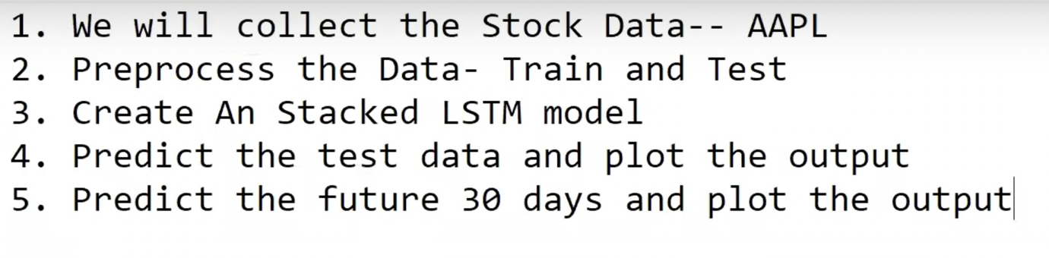

AAPL- stands for apple stock price

# We will be predicting the “**close**” column in the data-record taken from **Tiingo**.

**STEP1:- Collection of data-AAPL**

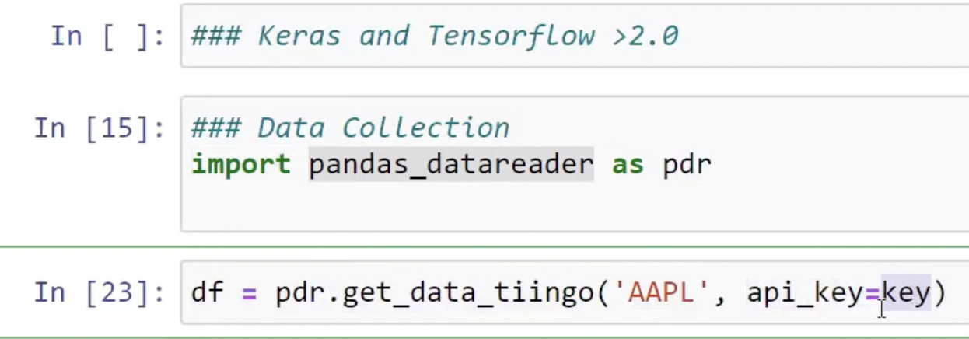

Data is collected from Tiingo using api_key.

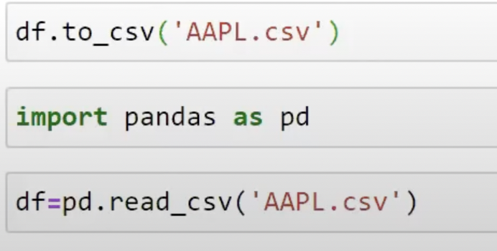

Data stored in .csv file and then read from it.

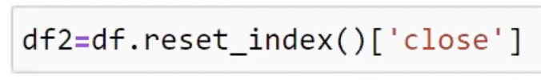

We are using “Close” column for our analysis

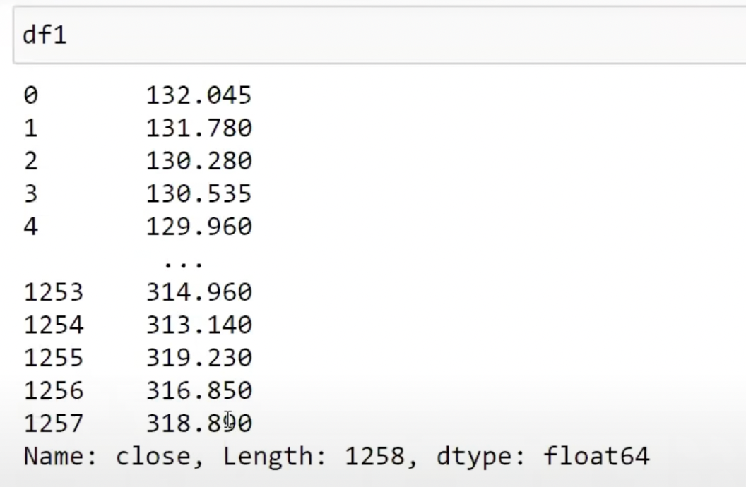

Converted Data record is shown above

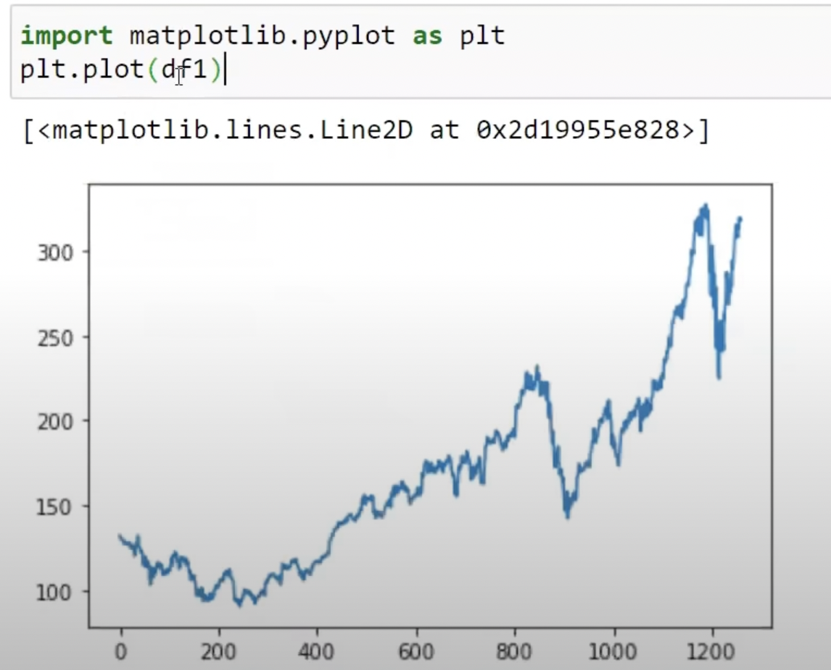

Data plot is shown in the above diagram

It shows the stock price from 2015 to 2020

**STEP 2:Preprocess and split the data**

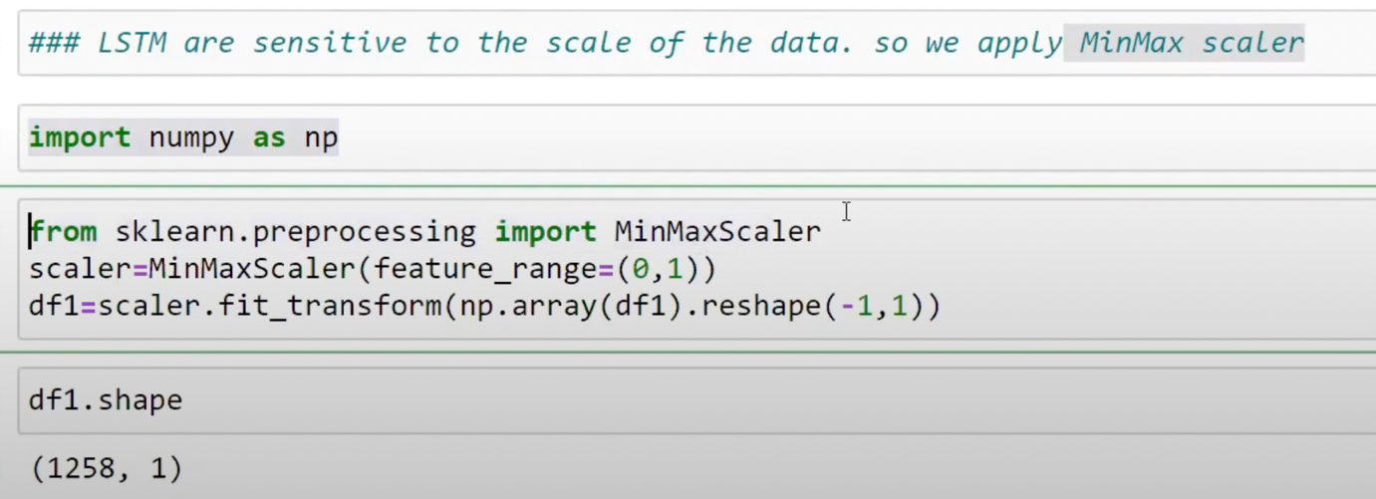

The above code will convert the given data set between 0 to 1 since feature range is (0,1).

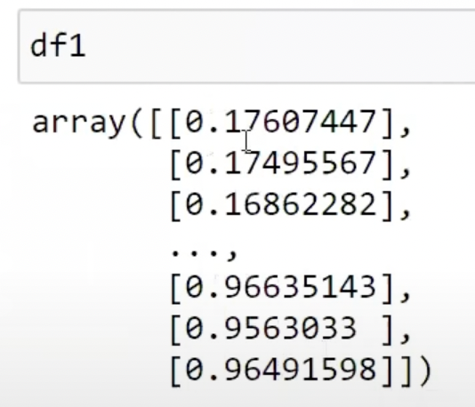

Now the new converted data record look like above(values are transformed between 0 to 1)

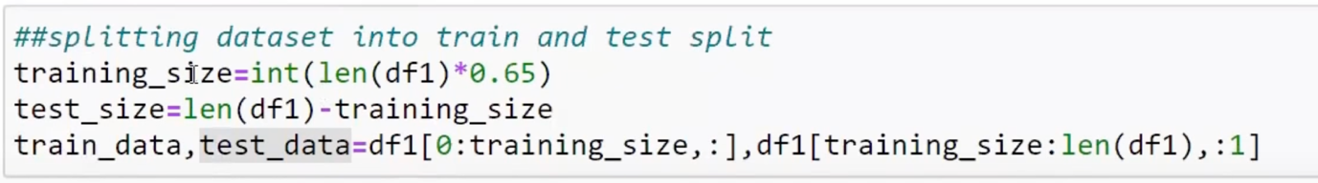

In above code segment data set is breaked into training and testing data and is done in ratio 65:35.

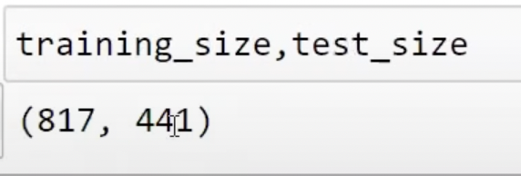

The above image shows the size of training and testing data.

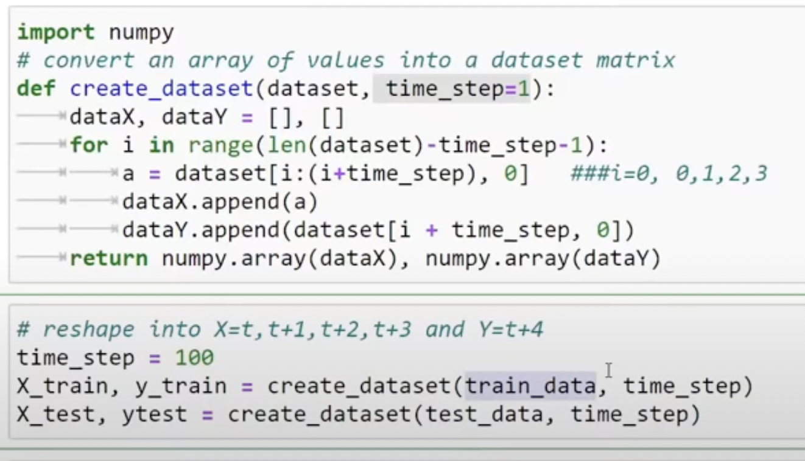

time_step =100 basically means that the current data depends on previous 100 records data.

higher is the time_step more accurate is the result.

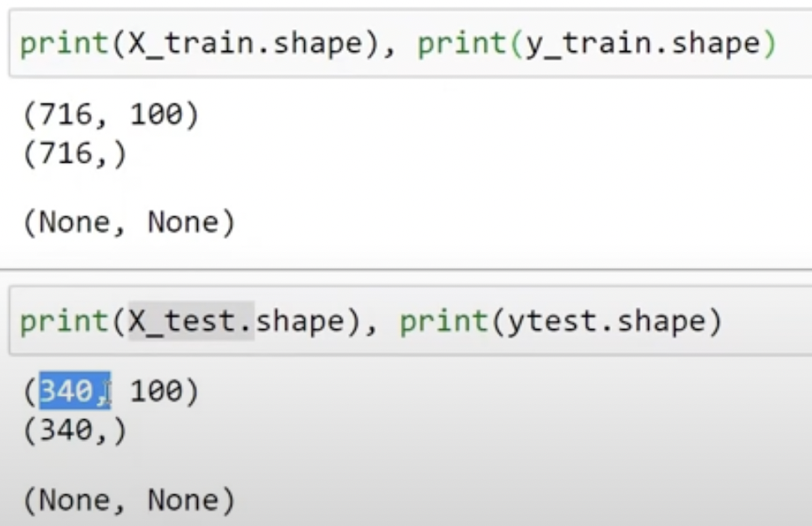

**STEP 3: CREATE A STACKED LSTM**

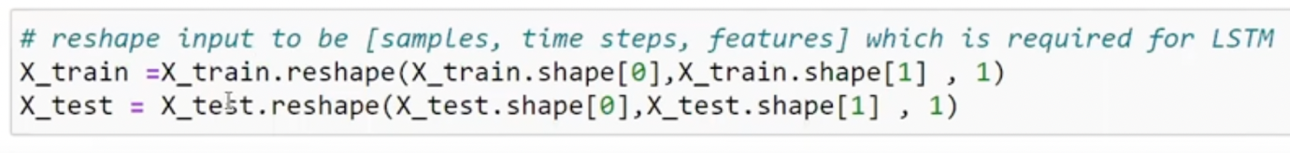

Converting the data into 3-Dimension so that it can be used as input for LSTM model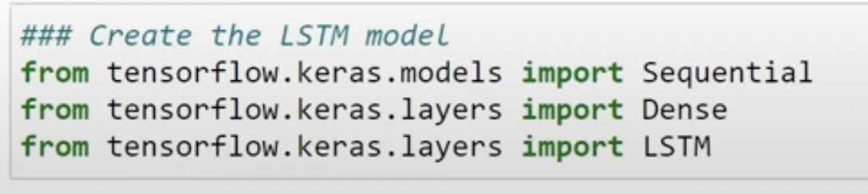

Above are the libraries required to run our stacked LSTM model.

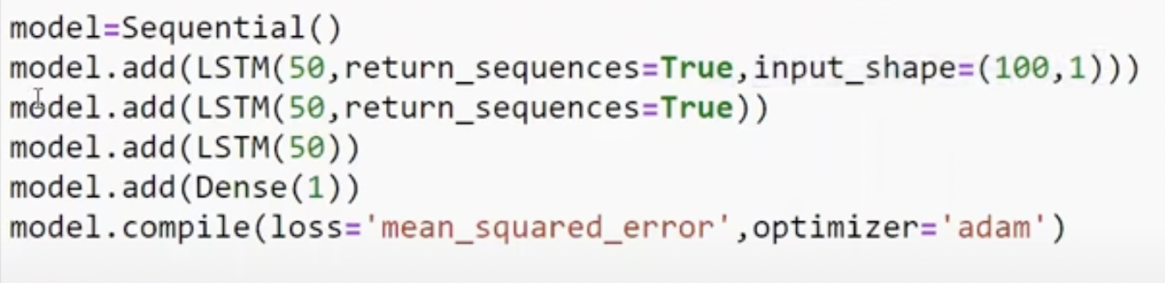

Optimizer used is “ADAM” & loss is calculated using MSE.

Why LSTM:-

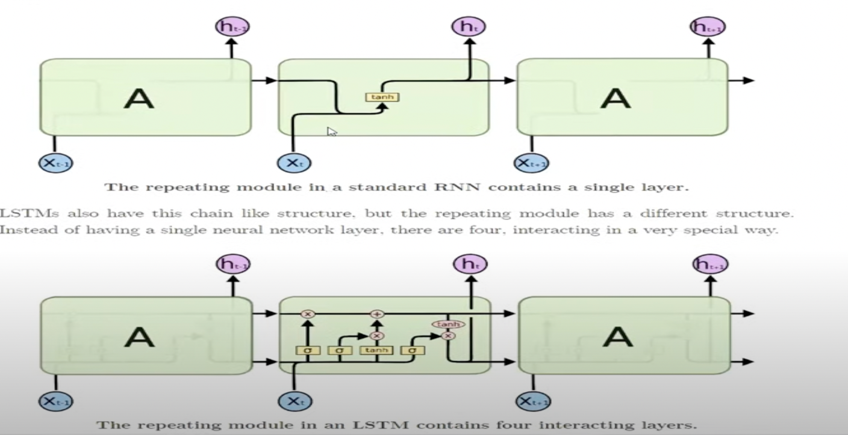

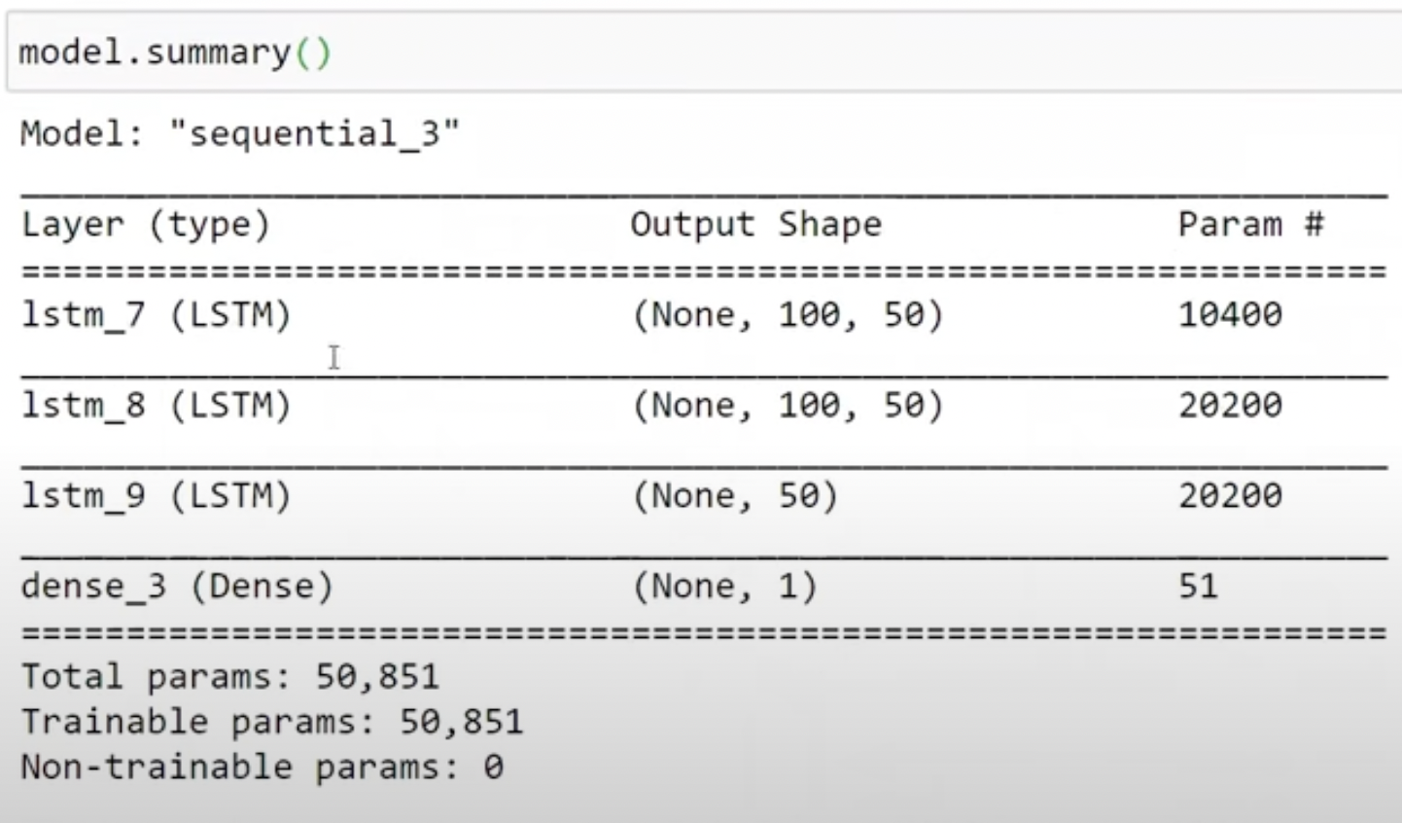



In above code segment Model is being trained.

**STEP 4:PREDICT THE TEST DATA AND PLOT THE OUTPUT**

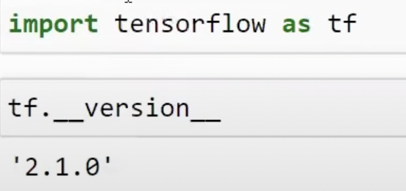

tensorflow is imported and version is ‘2.1.0’.

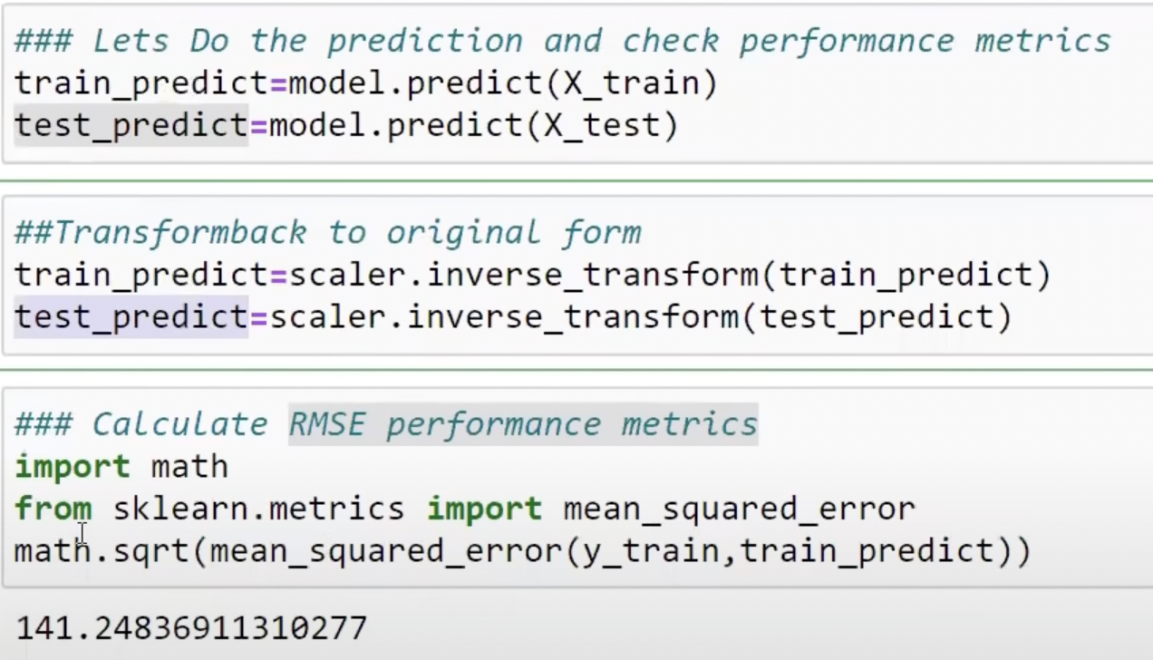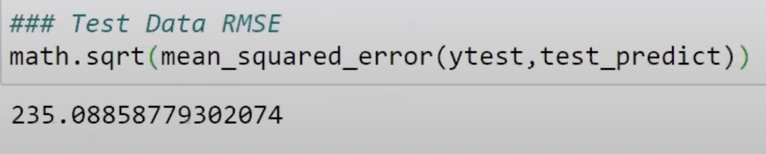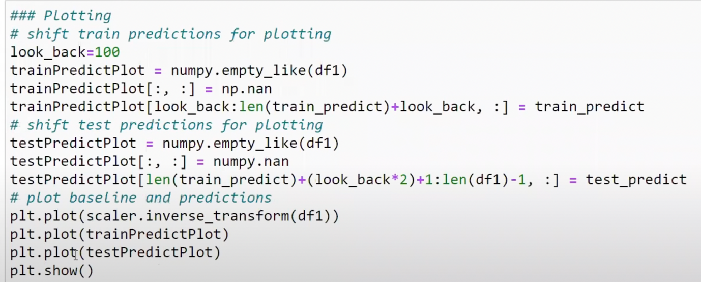

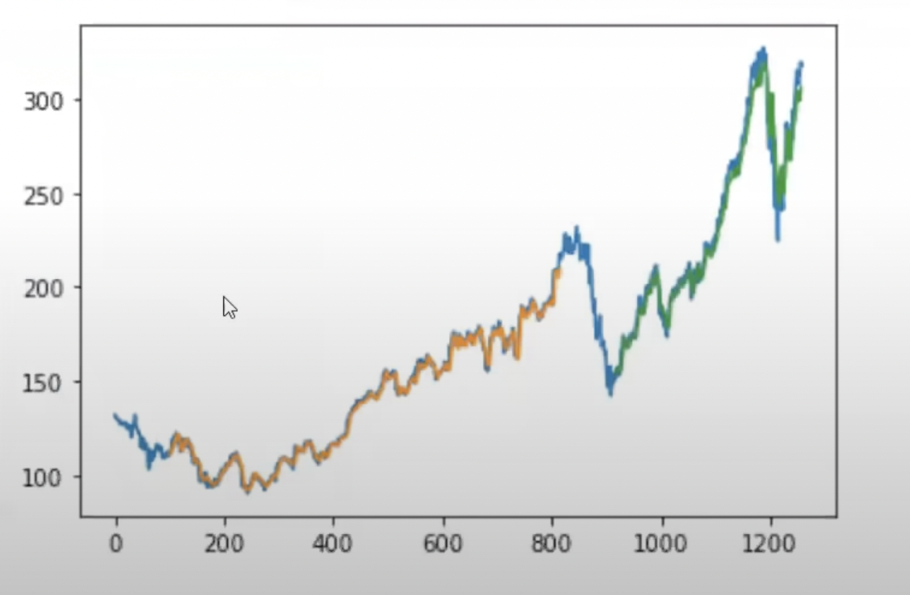

The blue curve = original data

The orange curve = predicted training data result

The blue curve = predicted testing data result

**STEP 5: PREDICT THE OUTPUT OF FUTURE 30 DAYS**

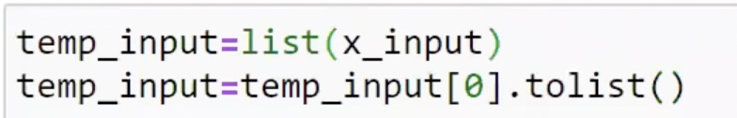

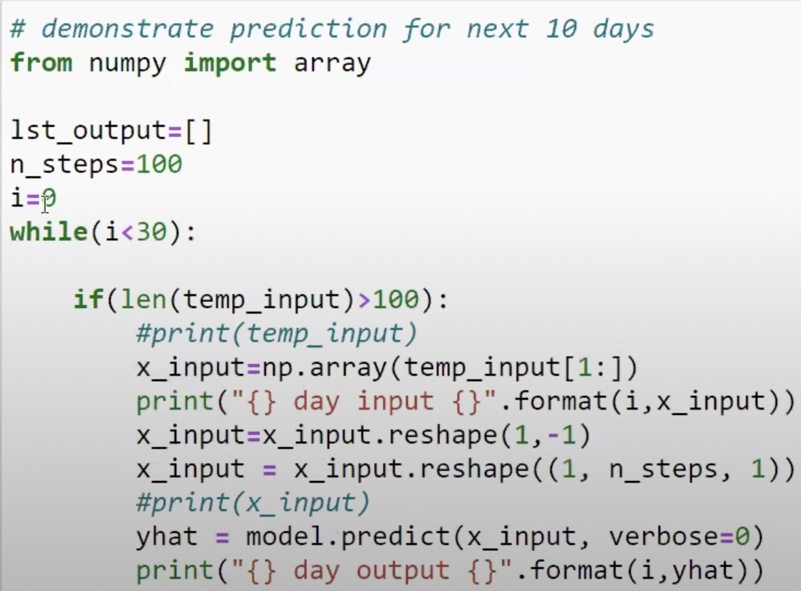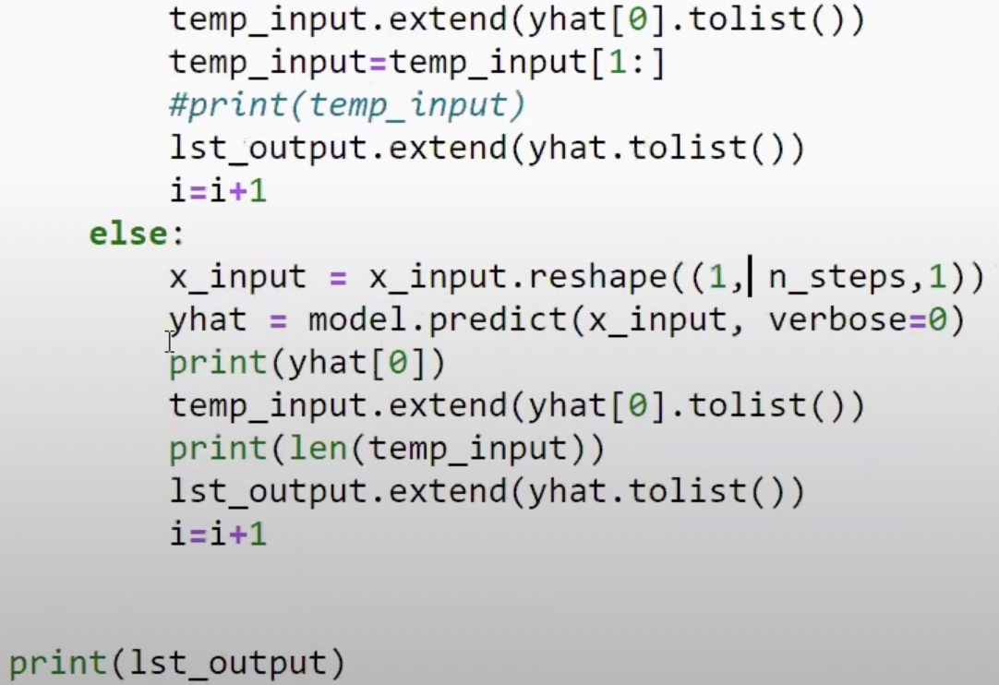

Running the model to predict output for next 30 days

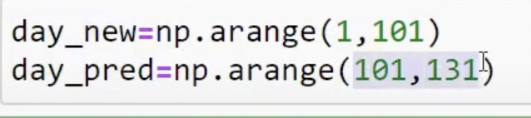 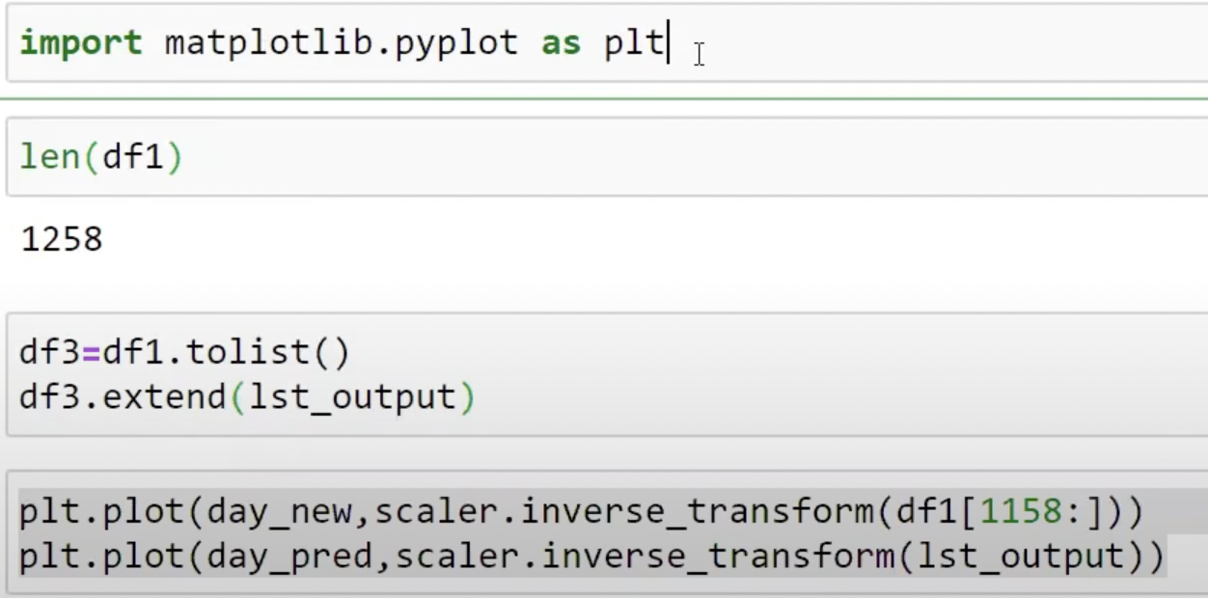

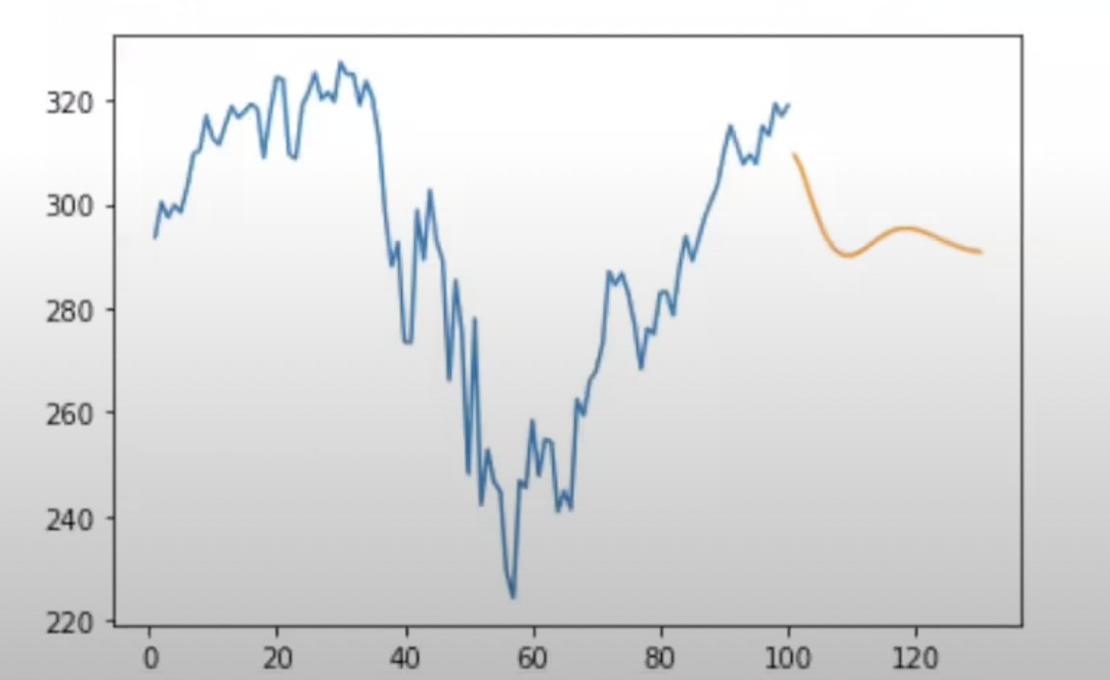

Above plot shows the output for next 30 days(the orange graph).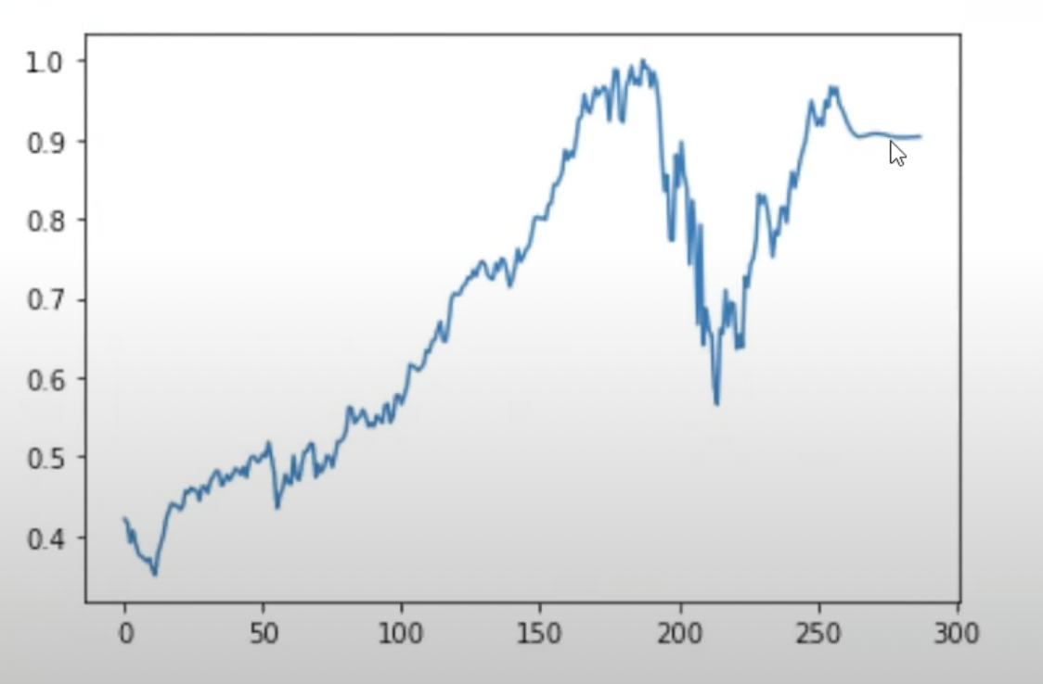

Complete output.

**Result and Conclusion**

RMSE of training data:141.2

RMSE of training data:235.8



Model Predicition on training and testing data

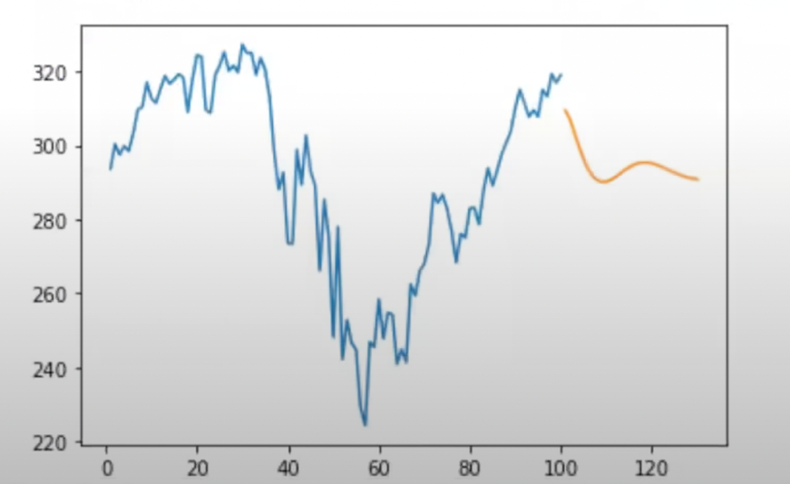

Model prediction for next 30 Days

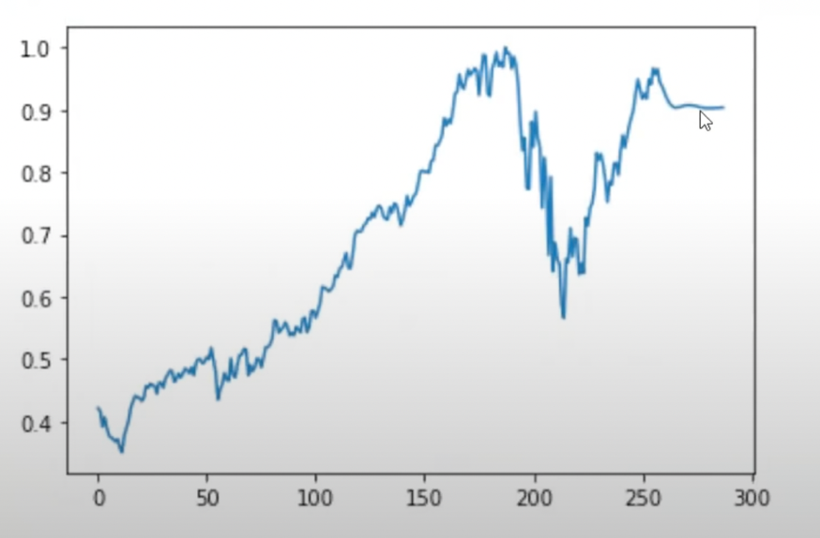

Complete Model prediction (including next 30 Days).